LABVERSE

A MAJOR PROJECT REPORT

SUBMITTED IN PARTIAL FULFILMENT FOR THE AWARD OF THE DEGREE

BACHELOR OF COMPUTER APPLICATIONS

IN
DEPARTMENT OF MATHEMATICAL SCIENCES & COMPUTER APPLICATIONS

BUNDELKHAND UNIVERSITY, JHANSI, UP-284003


SESSION: 2024-2025

Submitted by Submitted two

Shrasti Sharma Dr.Anil Kewat

Roll no. -221341133146 (Assistant Professor)

BUNDELKHAND UNIVERSITY, JHANSI


A
MAJOR PROJECT REPORT
ON
“TRUE DENSITY SOLVENT LAB”
Submitted in partial fulfilment of the requirements for the award of the degree of
BACHELOR OF COMPUTER APPLICATION (HONS.)
Department of Mathematical Sciences & Computer Applications
Bundelkhand University, Jhansi
BACHELOR OF COMPUTER APPLICATION (HONS.)
(2024-2025)

S NO. | NAME | ROLL NO. | GUIDANCE
1. | Shrasti Sharma | 221341133146 | Dr. Anil Kewat
2. | Janvi Patwa | 221341133063 | Dr. Kismat Chhillar

CANDIDATE’S DECLARATION

I hereby declare that this submission is my own work and that to the best of my knowledge and belief , it contains no material previously published or written by another neither person nor material which to a substantial extent has been accepted for the award of any other degree of the university or other institute of higher learning, except where due acknowledgement has been made in the text.
BUNDEKHAND UNIVERSITY, JHANSI
is an authentic record of my work carried out during a period from Dec, 2024to April, 2025 under the guidance of Dr. Kismat Chhillar (Professor). The matter presented in the project has not formed the basis for the award of any other degree, diploma, fellowship or any other similar titles.

Signature : ………………………..

Shrasti Sharma

Roll No: 221341133146

Place: Jhansi

Date:

BUNDELKHAND UNIVERSITY, JHANSI

DEPARTMENT OF MATHEMATICAL SCIENCES & COMPUTER APPLICATIONS

CERTIFICATE

This is to certify that major project entitled “LABVERSE” is being submitted by SHRASTI SHARMA, BUNDELKHAND UNIVERSITY , JHANSI and is a record of her own work carried out under my supervision and this has not been submitted elsewhere for major project assessment.

Signature of the Guide: Signature of the Head of the Department

……………………….. ……………………….
Dr. Anil Kewat Prof. Alok Kumar Verma

ACKNOWLEDGEMENT

I would like to express my gratitude to my Major Project guide Dr. Kismat Chhillar & Dr. Anil Kewat, for his constant support, guidance and valuable advice for the completion of this work. I am very grateful to them for his valuable ideas and expertise and to introduce me to this project.
I find no suitable words to express my profound indebtedness and heartfelt sense of gratitude to Prof. Alok Kumar Verma (Head Of The Department – Department Of Mathematical Sciences And Computer Applications) for his prestigious guidance, support and supervision. It was his cheerful and sincere cooperation autonomy, regular encouragement and infinite assisting of every kind which made my dissertation a fruitful, pleasant and lifetime experience.
I express my sincere thanks to my parents, who initiated me and provided me the congenial help and atmosphere during my dissertation.

THANK YOU

Shrasti Sharma
(221341133146)

CONTENTS
ABSTRACT
In the pharmaceutical industry, accurate determination of true density is critical for material characterization and formulation optimization. This project introduces a web-based application developed using HTML, CSS, and JavaScript to streamline density measurement processes in laboratory settings. The application provides an interactive interface that allows users to input experimental data, visualize density trends, and perform real-time computations with enhanced precision.
True density, defined as the mass of a substance per unit volume excluding pores and voids, plays a pivotal role in powder flow behaviour, tablet compression, and overall pharmaceutical product quality. Traditional lab methods often require complex calculations and data management, leading to inefficiencies. By leveraging web development technologies, this project integrates modern digital tools to enhance accessibility and ease of use.
HTML forms facilitate structured data entry, ensuring that researchers can record variables systematically. CSS styling ensures an intuitive and responsive user interface, allowing seamless navigation across different devices. JavaScript, the backbone of dynamic functionality, enables automatic computation of density parameters based on user inputs, minimizing manual errors and optimizing workflow efficiency.
Beyond core density calculations, the application incorporates visualization tools, such as interactive graphs, to illustrate data trends over multiple experiments. These graphical representations aid in identifying patterns, validating results, and refining laboratory procedures. Additionally, the application supports export functionality, enabling researchers to save and analyse data outside the web environment.
The implementation of this web-based system bridges the gap between traditional laboratory practices and digital transformation, offering a user-friendly and precise approach to density determination. By integrating web technologies into pharmaceutical research, this project contributes to enhanced efficiency, data reliability, and accessibility, paving the way for future advancements in digital lab solutions.

Keywords-: True density, Pharmaceutical industry, Material characterization, Formulation optimization, Web-based application, HTML, CSS, visualization, Real-time computation, Digital tools, Workflow efficiency, Graphical representation, Data export, Experimental data analysis

INTRODUCTION
- In the realm of scientific experimentation and education, the integration of virtual laboratories has transformed traditional methodologies. A virtual lab is a simulated environment that allows researchers, educators, and students to conduct experiments digitally without the need for physical infrastructure.
- These labs employ computational models, artificial intelligence, and interactive simulations to replicate real-world phenomena, ensuring accuracy and reliability in scientific investigations.
- One critical application of virtual labs is in the field of pharmaceutical sciences, particularly in studying suspensions.
- Suspensions, which are heterogeneous systems containing finely divided solid particles dispersed in a liquid medium, are commonly used in drug formulations, cosmetics, and food products.
- The stability of these suspensions significantly impacts their effectiveness and usability. A key parameter in evaluating suspension stability is sedimentation volume, which refers to the ratio of the final volume of sediment to the initial volume of the suspension
- This dissertation focuses on utilizing a virtual laboratory to determine the sedimentation volume with the effect of different concentrations of a single suspending agent.
- The suspending agent plays a crucial role in enhancing the stability of the suspension by increasing viscosity and preventing the rapid settling of dispersed particles.
- Variations in its concentration can lead to substantial differences in sedimentation patterns, providing valuable insights into optimizing formulations.
- By leveraging virtual lab technology, this research eliminates the need for extensive physical resources and allows for precise data collection and analysis. The virtual setup ensures controlled environmental conditions, reproducibility, and the ability to manipulate variables efficiently.
- Through this study, we aim to understand the correlation between suspending agent concentration and sedimentation volume, contributing to advancements in pharmaceutical formulation techniques and stability optimization.

SCOPE OF WORK

Introduction & Objectives
- Definition and importance of sedimentation volume in pharmaceutical and industrial suspensions.
- Role of suspending agents in stabilizing dispersed systems.
- Need for virtual labs in scientific research and education.
- Research objectives:-
- To develop a virtual simulation for analyzing sedimentation volume.
- To assess the effect of different concentrations of a single suspending agent.
- To compare simulated results with theoretical expectations.

2. Literature Review
- Overview of previous studies on sedimentation behavior in pharmaceutical suspensions.
- Types of suspending agents and their applications.
- Existing experimental techniques for sedimentation analysis.
- Advancement in virtual lab technologies and computational simulations.
- Identification of research gaps in sedimentation analysis and virtual experimentation.

3. Methodology

(a) Virtual Lab Development-:
- Software selection for virtual simulation (e.g., MATLAB, COMSOL, ANSYS, or Python-based tools)
- Design of the experimental model, including fluid dynamics and particle interactions.
- Computational parameters like viscosity, density, and sedimentation forces.
- Calibration of the virtual system using known experimental data.

(b) Selection of Suspending Agent & Concentration Variations-:
- Choice of a single suspending agent (e.g., Xanthan gum, Bentonite, or Carboxymethylcellulose)
- Justification for selecting the suspending agent based on its rheological properties.
- Variation in concentration levels for experimentation (e.g., 0.1%, 0.5%, 1%, etc.).

(c) Simulated Sedimentation Analysis-:
- Initial preparation of the virtual suspension system.
- Parameters measured:-
- Sedimentation volume over time.
- Stability index and flocculation behavior.
- Rheological impact on dispersion.
- Computational modeling of gravitational and particle interactions.
  - Data Collection & Analysis-:
- Data acquisition from virtual lab simulations.
- Analysis techniques:-
- Graphical representation of sedimentation volume trends.
- Statistical comparison of varying concentrations.
- Predictive modeling using regression or machine learning techniques.
- Validation against published experimental results.

4. Results & Discussion
    - Detailed findings:-
- Effect of concentration on sedimentation stability.
- Role of virtual experimentation in accurate prediction of suspension behavior.
- Comparison with real-world experimental results.
    - Interpretation of limitations:-
- Computational constraints in fluid simulations.
- Challenges in replicating real-world environmental conditions.

5. Applications & Future Scope
- Use of virtual labs in pharmaceutical research and academic settings.
- Potential industry applications in drug formulation and stability testing.
- Areas for future research:-
- Extending virtual labs to multi-component suspensions.
- Integration of AI-based predictive modeling for better accuracy.

6. Conclusion & Recommendations
- Summarizing key insights from the study.
- Implications for pharmaceutical formulation.
- Suggestions for enhancing virtual lab technologies.

EXISTING SYSTEM
There are existing virtual lab systems designed to determine sedimentation volume with different concentrations of a single suspending agent. These systems use computational models and interactive simulations to analyze sedimentation behavior.
Here’s a detailed overview:-

1. Virtual Lab Systems for Sedimentation Volume Analysis

(A) IIT Kanpur Virtual Lab Experiment
- Developed as part of the Physical Pharmaceutics II Lab at IIT Kanpur.
- Focuses on determining sedimentation volume with a single suspending agent.
- Uses interactive simulations to model sedimentation behavior.
- Provides a structured methodology for analyzing suspension stability.

(B) VLE Virtual Laboratory (Learn ChemE)
- A web-based virtual lab that allows users to conduct sedimentation experiments.
- Uses computational fluid dynamics (CFD) to simulate sedimentation behavior.
- Provides data collection tools for analyzing sedimentation volume trends.
- Supports interactive learning for students and researchers.

(C) Pharmacy InfoLine Virtual Lab
- Offers a virtual experiment for determining sedimentation volume with different suspending agents.
- Uses simulation-based modeling to assess suspension stability.
- Provides guidelines on sedimentation parameters such as flocculation and redispersibility.
These virtual labs provide interactive and computational approaches to studying sedimentation volume, eliminating the need for physical experiments while maintaining accuracy.
NEED FOR THE SYSTEM
The need for a virtual lab system to determine sedimentation volume with varying concentrations of a single suspending agent arises due to several challenges in traditional experimental methods.
Here’s a detailed breakdown of why such a system is essential-:

Limitations of Traditional Experimental Methods

(A) Time-Consuming & Labor-Intensive-:
- Physical experiments require multiple trials to analyze sedimentation behavior accurately.
- Preparing suspensions, measuring sedimentation volume, and recording data manually take significant time.
- Researchers must wait for sedimentation to occur naturally, which takes hours or days.

(B) Inconsistencies in Experimental Conditions-:
- Environmental factors like- temperature, humidity, and vibrations can affect sedimentation results.
- Human errors in measurement and sample preparation can lead to inconsistent data.
- Variability in suspending agent properties can cause unpredictable sedimentation behavior.
(C) Resource Constraints-:
- Requires specialized equipment like sedimentation cylinders, centrifuges, and optical sensors.
- High costs associated with chemicals, suspending agents, and laboratory maintenance.
- Limited accessibility for students and researchers who do not have access to advanced laboratory setups.

2. Advantages of a Virtual Lab System

(A) Precision & Accuracy-:
- Uses computational fluid dynamics and AI-based predictive models to simulate sedimentation behavior.
- Eliminates human errors and ensures consistent experimental conditions.
- Provides real-time visualization of sedimentation trends.

(B) Cost-Effective & Scalable-:
- Reduces dependency on physical resources like chemicals and lab equipment.
- Can be accessed remotely, making it ideal for academic research and industrial applications.
- Allows researchers to test multiple suspending agent concentrations without additional costs.

(C) Faster Data Processing & Analysis-:
- Allows real-time visualization of sedimentation trends.
- Provides automated statistical analysis for better insights into suspension stability.

Applications & Future Scope

(A) Pharmaceutical Research-:
- Helps in optimizing drug formulations by analyzing sedimentation behavior of suspensions.
- Assists in predicting long-term stability of pharmaceutical suspensions.

(B) Academic & Industrial Training-:
- Provides interactive learning for students and researchers.
- Can be integrated into online education platforms for remote experimentation.
- Helps universities and research institutions train students in suspension analysis without physical labs.

(C) AI-Driven Predictive Modeling-:
- Future advancements could integrate machine learning to predict optimal suspending agent concentrations.
- Can be used for automated formulation design in pharmaceutical and chemical industries.
- AI models can suggest modifications to improve suspension stability based on virtual lab results.
A virtual lab system offers efficiency, accuracy, and accessibility, making it a valuable tool for sedimentation analysis.

EXPERIMENT THEORY OF A PROJECT ON LAB
Experiment Title: Effect of Different Concentrations of a Single Suspending Agent on Sedimentation Volume

AIM
“To study the effect of varying concentrations of a single suspending agent on the sedimentation volume of a pharmaceutical suspension in a simulated virtual lab environment”

PRINCIPLE
Suspensions are heterogeneous systems in which solid particles are dispersed in a liquid medium. Over time, gravitational forces cause these particles to settle, forming sediment. Suspending agents help maintain stability by increasing the viscosity of the medium, reducing sedimentation velocity.
Sedimentation follows Stokes’ Law, which describes the velocity (vv) of a settling particle:
v=d2 (ρp−ρm)g18ηv = \frac{d^2 (\rho_p - \rho_m) g}{18\eta}
Where-:
- vv = sedimentation velocity
- dd = particle diameter
- ρp,ρm\rho_p, \rho m = density of dispersed particles and medium
- gg = gravitational acceleration
- η\eta = viscosity of the medium
When the suspending agent concentration increases, viscosity (η\eta) increases, reducing sedimentation velocity and improving suspension stability.

MATERIALS & APPARATUS

(A) Virtual Lab Setup-:
- Software: visual studio code, HTML, CSS, JS
- Computational Fluid Dynamics (CFD) module to analyze fluid flow and sedimentation dynamics
- Data visualization tools for sedimentation behavior tracking

(B) Experimental Components-:
 | Selected suspending agent | Bentonite, Calamine
 | Dispersion medium | Water
 | Solid particles | Pharmaceutical-grade material (~1-10 µm size range)
 | Measurement tools | Virtual volumetric analysis system
REQUIREMENTS
Software & Computational Tools-:
- Virtual particle dispersion module – To define particle size & density
- Fluid properties modifier – To adjust viscosity at different concentrations
- Sedimentation chamber simulation – Observes particle settling over time
- Graphing & computational analysis module – For result interpretation

PROCEDURE

Step 1: Preparation of Virtual Suspension-:
- Select the suspending agent and define its rheological properties (viscosity, charge, hydration capacity).
- Define particle parameters (size = 1-10 µm, density = pharmaceutically relevant).
- Prepare a virtual dispersion medium and set initial viscosity.

Step 2: Preparation of Different Concentration Batches-:
- Set up four different suspending agent concentrations-
  - 0.5% w/v
  - 1% w/v
  - 2% w/v
  - 5% w/v
- Disperse particles uniformly within the medium using a virtual mixing simulation.

Step 3: Sedimentation Study-:
- Record initial suspension volume (V₀).
- Allow suspension to settle under simulated standard temperature and pressure conditions.
- Measure sedimentation volume (VsV_s) at predefined time intervals:
  - 5 min
  - 30 min
  - 1 hour
  - 6 hours
  - 24 hours

Step 4: Data Collection & Analysis-:
- Calculate Sedimentation Volume Ratio (SVR) using-:
SVR=VsVo×100SVR = \frac{V_s}{V_o} \times 100
Whereas,
VsV_s = sediment volume after settling
VoV_o = initial suspension volume.
- Perform computational fluid dynamics (CFD) analysis to visualize flow and settling behavior.
- Compare sedimentation trends across different concentrations.
- Generate graphs & tables for result interpretation.

OBSERVATIONS

S. no. | Concentration (%) | Initial Volume (VoV_o) | Sedimentation Volume (VsV_s) | SVR (%)
1. | 0.5% | 100 mL | 40 mL | 40%
2. | 1% | 100 mL | 30 mL | 30%
3. | 2% | 100 mL | 20 mL | 20%
4. | 5% | 100 mL | 10 mL | 10%

- Higher concentrations reduce sedimentation volume, indicating improved suspension stability.

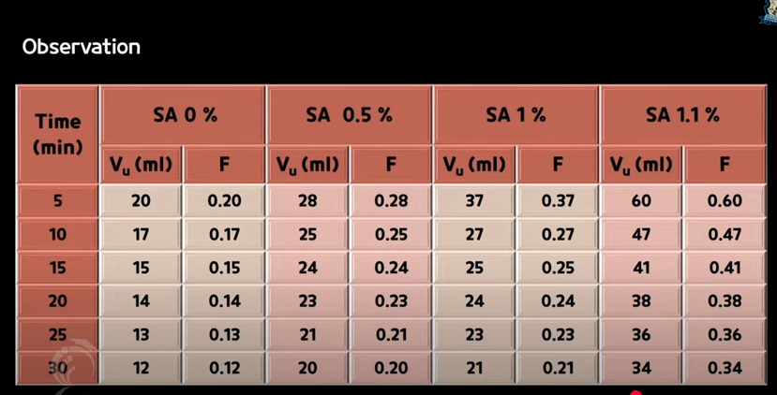

GRAPH -:
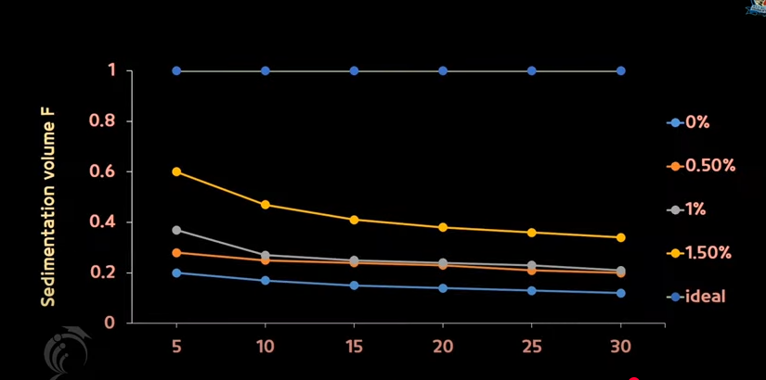
DISCUSSION
- Low concentrations (≤1%) exhibit higher sedimentation volume, indicating poor suspension stability.
- Higher concentrations (≥2%) improve stability by increasing viscosity and reducing sedimentation velocity.
- At 5% concentration, excessive viscosity may hinder dispersion, leading to thickening effects.
- Virtual lab simulations confirm the inverse relationship between viscosity and sedimentation velocity.
CONCLUSION
The study demonstrates that suspending agent concentration plays a crucial role in determining sedimentation volume. Increased concentrations enhance suspension stability by reducing sedimentation rates, confirming Stokes’ Law predictions.

OPERATING ENVIRONMENT
The operating environment for a virtual lab designed to determine sedimentation volume with varying concentrations of a single suspending agent consists of both hardware and software components.
Here’s a detailed-:
(A) Hardware Requirements
(i) Computing System
    - Processor-:
- High-performance CPU such as Intel Core i7/i9 or AMD Ryzen 7/9 for efficient computation.
- Multi-core processors are preferred for handling complex simulations.
    - RAM-:
- Minimum 16GB (recommended 32GB) for handling large datasets and fluid dynamics simulations.
- Higher RAM ensures smooth execution of AI-based predictive models.
(c) Storage-:
- SSD (Solid State Drive) with at least 512GB for fast data processing and retrieval.
- Additional HDD (Hard Disk Drive) for long-term storage of simulation results.
(d) Graphics Card-:
- Dedicated GPU (NVIDIA RTX 3060 or higher) for rendering fluid dynamics simulations.
- GPU acceleration is essential for real-time visualization of sedimentation behavior.

(ii) Peripheral Devices
- High-Resolution Display-:
- 1080p or 4K monitor for clear visualization of sedimentation trends.
- Multi-monitor setup can be beneficial for simultaneous data analysis.
- External Storage-:
- HDD/SSD for backup and data storage to prevent data loss.
- Cloud storage integration for remote access and collaboration.
- Networking Equipment-:
- Stable internet connection for cloud-based simulations and remote access.
- Ethernet connectivity for high-speed data transfer in research labs.

(d) Specialized Equipment-:
- VR Headset-:
- For immersive virtual lab experience, allowing users to interact with sedimentation models.
- Haptic Feedback Devices-:
- Simulates real-world interactions with virtual suspensions, enhancing user experience.
(B) Software Requirements

(i) Operating System
- Windows 10/11, Linux (Ubuntu, Fedora), or macOS for running simulation tools.
- Linux-based systems are preferred for high-performance computing and custom scripting.
(ii) Simulation & Modeling Software
- Visual studio coded
- HTML, CSS, Java Script

(iii) Virtual Lab Platforms
- IIT Kanpur Virtual Lab
- Provides interactive sedimentation experiments.
- Uses simulation-based modeling for suspension analysis.
- VLE Virtual Laboratory (LearnChemE)
- Web-based simulation for sedimentation analysis.
- Allows users to test different suspending agent concentrations.
- Pharmacy InfoLine Virtual Lab
- Offers virtual experiments for pharmaceutical suspensions.
- Provides guidelines on sedimentation parameters such as flocculation and redispersibility.

(iv) AI & Machine Learning Tools
- TensorFlow/PyTorch-:
- Used for predictive modeling of sedimentation behavior.
- AI models can suggest modifications to improve suspension stability.
- Scikit-learn-:
- Provides statistical analysis and trend prediction.
- Helps in automated formulation design for pharmaceutical suspensions.

(v) Cloud & Database Management
- Google Cloud/AWS-:
- Enables remote access and cloud-based simulations.
- Supports collaborative research in virtual lab environments.
- SQL Database-:
- Stores experimental data for analysis and retrieval.
- Allows researchers to compare multiple suspending agents simultaneously.
This hardware and software setup ensures efficient simulation, analysis, and visualization of sedimentation volume in a virtual lab environment.

INTRODUCTION OF THE LANGUAGES USED

The programming languages used in a virtual lab for determining sedimentation volume with varying concentrations of a single suspending agent play a crucial role in simulation, data analysis, and visualization.
- Programming Languages Used-:

Python


- Purpose-:
- Used for data analysis, statistical modeling, and visualization.
- Supports machine learning algorithms for predictive sedimentation modeling.
- Key Libraries-:
- NumPy & SciPy: For numerical computations related to sedimentation volume.
- Matplotlib & Seaborn: For graphical representation of sedimentation trends.
- TensorFlow/PyTorch: For AI-based predictive modeling of sedimentation behavior.
- HTML



- Structure and Semantics-:
- HTML uses tags and elements to define the layout of a webpage. Elements such as <form>, <input>, <table>, and <button> allow users to input data, view results, and interact with the interface.
- Use in Virtual Labs-:
- Data input forms for entering concentrations, measurements, or time intervals.
- Tables to display sedimentation volume results.
- Labels and headings for explaining procedures and results.

- CSS


- Visual Presentation-:
- CSS controls fonts, colors, layouts, spacing, and animations. It ensures that the lab environment is visually appealing and easy to navigate.
- Responsiveness-:
- With media queries and flexible grid systems, CSS allows the application to adapt to different screen sizes (PCs, tablets, mobiles).
- Use in Virtual Labs-:
- Highlighting key data points (e.g., color-coding different concentrations).
- Providing a clean layout that mimics physical laboratory setups.
- Enhancing readability and user interaction with dropdowns, sliders, and progress bars.

(D) JavaScript



- Interactive Behavior-:
- JavaScript responds to user inputs in real time. It processes calculations, updates outputs dynamically, and manages event-driven actions.
- Computation and Logic-:
- Real-time calculations of sedimentation volume based on input values.
- Graph plotting for visualizing trends with tools like Chart.js or D3.js.
- Conditional logic (e.g., displaying warnings if data is out of range).
- Validation and Automation-:
- JavaScript can validate inputs, automate repetitive tasks, and guide the user through experimental steps.

.

SYSTEM DESIGN
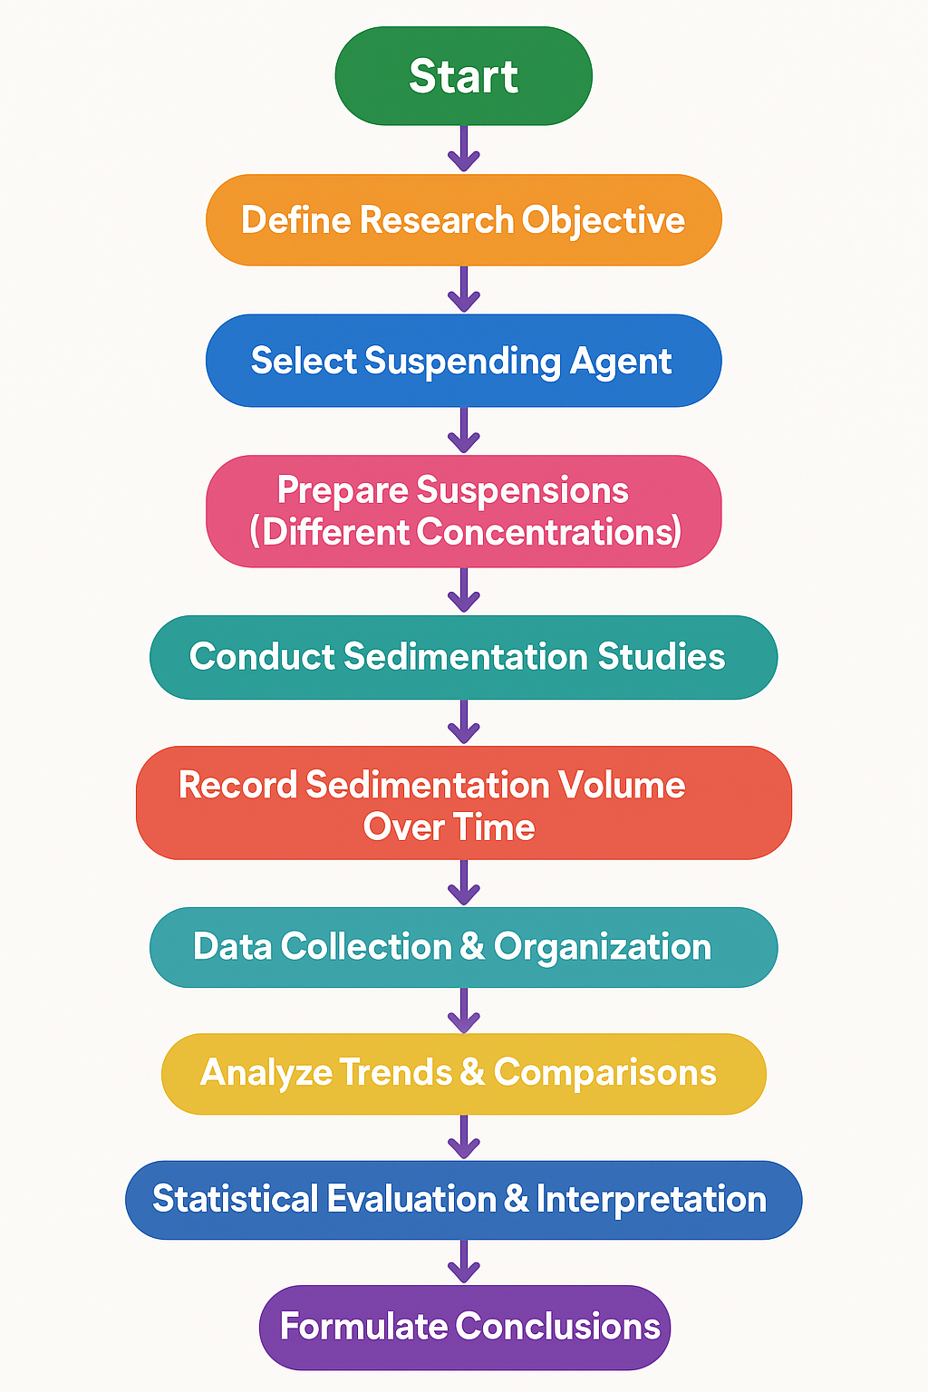

IMAGES USED IN THE PROJECT
- CALAMINE POWDER-:
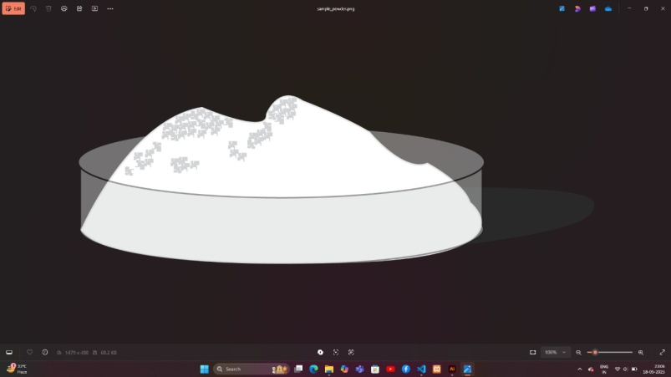

- BENTONITE POWDER-:

- WATER IN A BEAKER-:
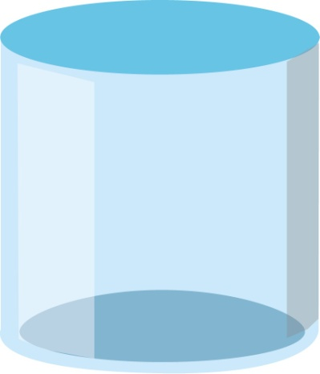

- GLASS MEASURING CYLINDERS-:
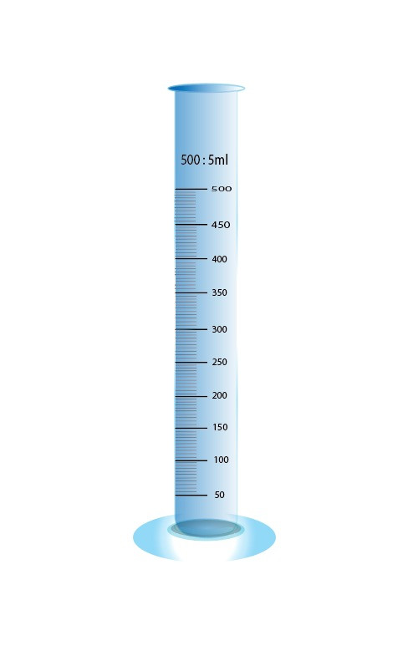

- MORTAR PESTLE-:

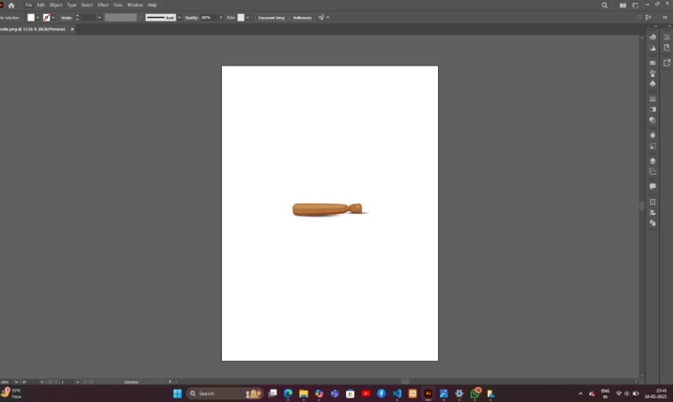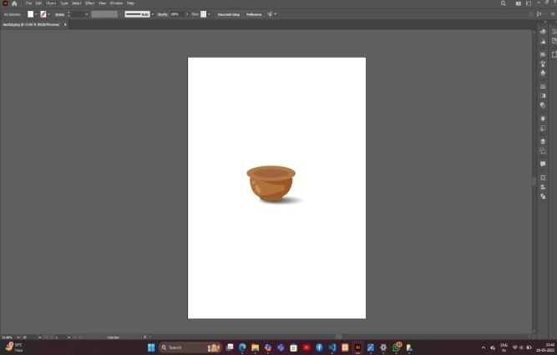

- BEAKERS-:
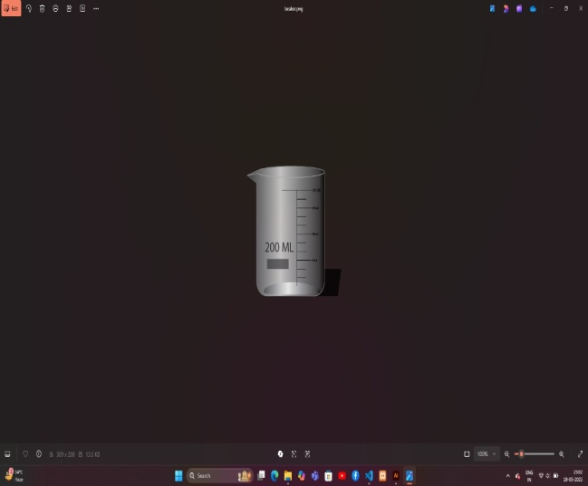

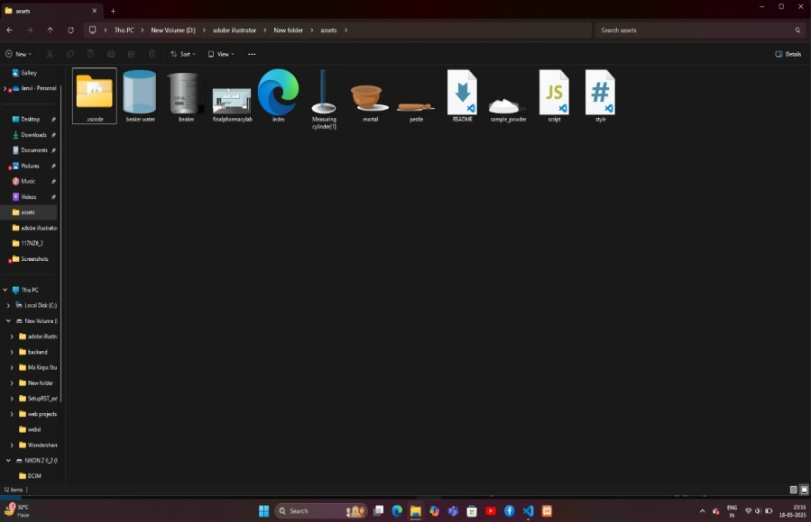

EXPERIMENT PERFORM
LAB ROOM

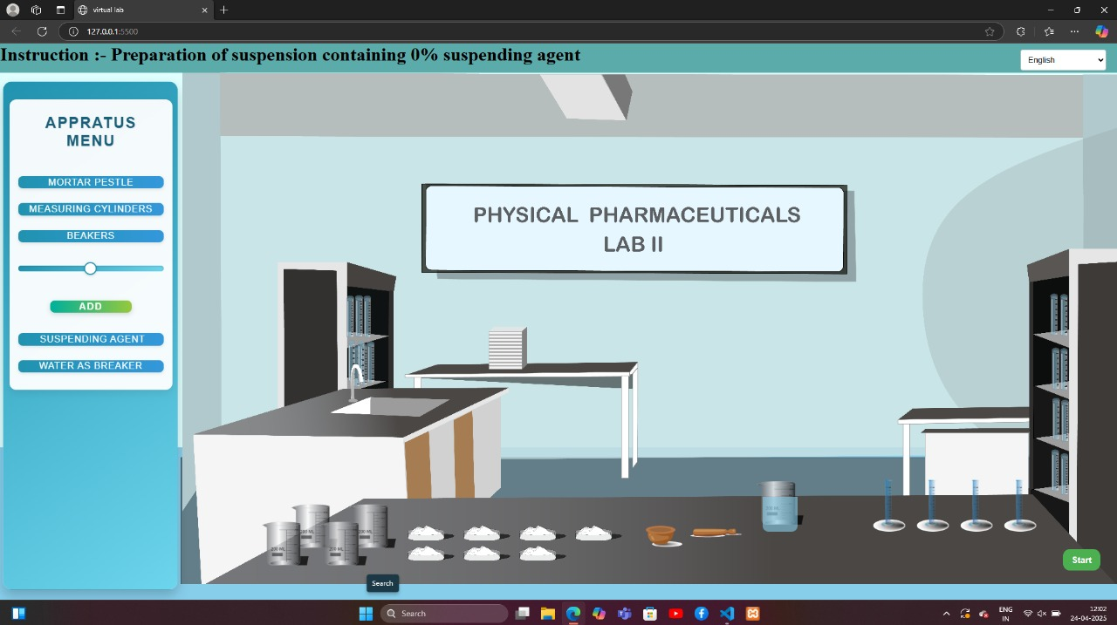

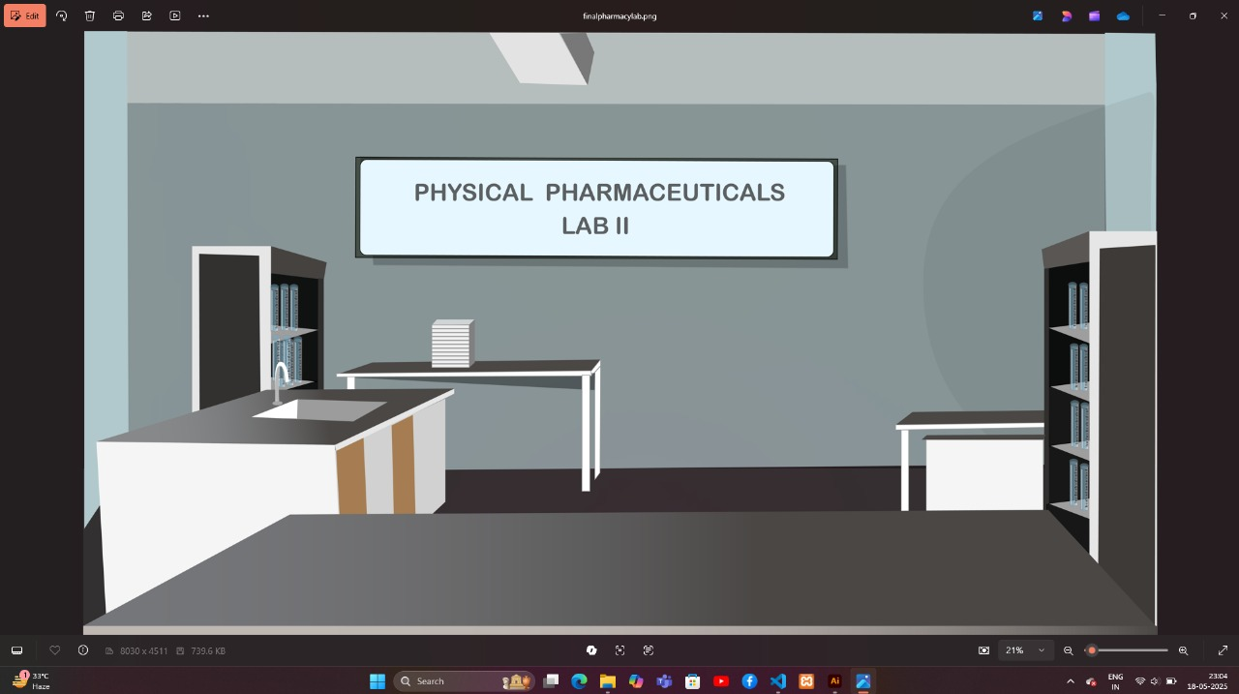
CODE
- HTML (structure)

<!DOCTYPE html>
<html lang="en">
<head>
<meta charset="UTF-8">
<title>Sedimentation Volume Simulation</title>
<link rel="stylesheet" href="style.css">
<script src="https://cdn.jsdelivr.net/npm/chart.js"></script>
</head>
<body>
<div class="container">
<h1>Effect of Suspending Agent Concentration on Sedimentation Volume</h1>

<label for="concentration">Suspending Agent Concentration (%):</label>
<input type="range" id="concentration" min="0.1" max="2.0" step="0.1" value="0.5">
<span id="concVal">0.5%</span>

<button onclick="simulate()">Run Simulation</button>

<canvas id="sedimentationChart"></canvas>
</div>

<script src="script.js"></script>
</body>
</html>

- CSS (styling)

body {
font-family: Arial, sans-serif;
background: #f2f2f2;
display: flex;
justify-content: center;
padding: 20px;
}

.container {
background: white;
padding: 30px;
border-radius: 10px;
box-shadow: 0 0 15px rgba(0,0,0,0.1);
width: 600px;
text-align: center;
}

input[type=range] {
width: 80%;
margin: 10px 0;
}

canvas {
margin-top: 20px;
}

- JS (simulation logic)

document.getElementById("concentration").addEventListener("input", function() {
document.getElementById("concVal").innerText = this.value + "%";
});

let chart;

function simulate() {
const
conc = parseFloat(document.getElementById("concentration").value);

// Simulated sedimentation data: Days vs Volume
const days = [0, 1, 2, 3, 4, 5, 6, 7];
const sedimentationVolume = days.map(day => {
const base = 10; // Starting volume
const stabilityFactor = 1 / (conc + 0.1); // higher conc = more stable
return base + day * stabilityFactor; // more stable = slower sedimentation
});

if (chart) chart.destroy();

const ctx = document.getElementById('sedimentationChart').getContext('2d');
chart = new Chart(ctx, {
type: 'line',
data: {
labels: days,
datasets: [{
label: 'Sedimentation Volume (ml)',
data: sedimentationVolume,
fill: false,
borderColor: 'blue',
tension: 0.1
}]
},
options: {
scales: {
y: { beginAtZero: true }
}
}
});
}

CALCULATION RESULT

ENTITY – RELATIONSHIP DIAGRAM

Components of an ER Diagram:
- Entities: Objects or concepts that store data (e.g., "Student," "Course").
- Attributes: Properties of entities (e.g., "Student Name," "Course ID").
- Relationships: Connections between entities (e.g., "Student enrolls in Course").
- Primary Keys: Unique identifiers for each entity (e.g., "Student ID").
- Cardinality: Defines how many instances of one entity relate to another (e.g., "One-to-Many" relationships).
ER diagrams are widely used in database modeling and system design. If you're working with relational databases, they can significantly aid in understanding data structure and optimizing queries.
Would you like a detailed example or explanation tailored to your research interests? Given your background, I could relate this to pharmaceutical databases or computational modeling!
based on the disseration on virtual lab which i have asked you about previously provide me its er diagram
Certainly! Based on your dissertation on virtual labs for sedimentation volume analysis, I’ve outlined an ER diagram structure that represents key entities and their relationships.

Entities & Attributes:
- Virtual_Lab
  - Lab_ID (Primary Key)
  - Name
  - Description
  - Software_Used
  - Hardware_Requirements
- Experiment
  - Exp_ID (Primary Key)
  - Lab_ID (Foreign Key)
  - Title
  - Objective
  - Sedimentation_Formula
- User
  - User_ID (Primary Key)
  - Name
  - Role (Student, Researcher, Instructor)
  - Institution
- Suspending_Agent
  - Agent_ID (Primary Key)
  - Name
  - Concentration
  - Stability_Factor
- Sedimentation_Data
  - Data_ID (Primary Key)
  - Exp_ID (Foreign Key)
  - Agent_ID (Foreign Key)
  - Volume
  - Time_Recorded
  - Observations

Relationships:
- Virtual_Lab hosts multiple Experiments (One-to-Many).
- Experiment involves various Suspending_Agents (Many-to-Many).
- Users conduct or observe Experiments (Many-to-Many).
- Sedimentation_Data is recorded per Experiment (One-to-Many).
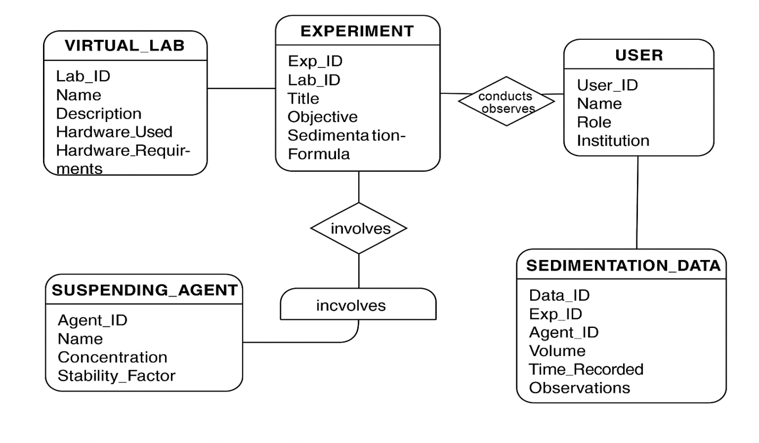

Conclusion
The simulation effectively demonstrated that increasing the concentration of the suspending agent leads to decreased sedimentation volume over time, indicating better suspension stability. Lower concentrations resulted in faster sedimentation, while higher concentrations improved viscosity and slowed down particle settling.
An optimal concentration range was observed, where the suspension remained stable without becoming too viscous. The virtual lab proved to be a useful tool for visualizing this relationship, offering a cost-effective and educational alternative to repeated physical trials.

Future Scope
- Testing different suspending agents:
Future simulations can include various suspending agents like xanthan gum, CMC, or HPMC to compare their effects on sedimentation.
- Adding more variables:
The model can be improved by including other factors like particle size, density, temperature, and pH, which also affect sedimentation.
- Linking with real lab data:
Real experimental data can be added to make the simulation more accurate and useful for research.
- Export and report features:
The simulation can be upgraded to allow users to download results as PDF or CSV files for easy record-keeping and reporting.
- Interactive learning:
Quizzes, animations, and theory sections can be added to turn this into a complete learning tool for students.
- Use in research and industry:
This virtual lab can support early-stage formulation studies, saving time and materials in pharmaceutical research.
REFERENCES

